Fabric Workspace Settings - Architecture
Table of Contents

Fabric Workspace Settings - Architecture

Scope of this document
This document describes the architecture of the Fabric Workspace Settings solution - a Power Platform application that lets Fabric workspace owners configure Git integration, outbound access, and managed private endpoints for the workspaces they own, without holding the Fabric Workspace Admin role.
Companion documents
Document | Answers
Permissions | Which rights every party must hold, and who grants them
Security | Security requirements, controls, trust boundaries and residual risk
Migration | Everything that must be done to stand the solution up in a new tenant or environment
Build-level detail - per-flow logic, connector definition, canvas app construction - lives in the separate engineering documentation set.

1. The problem
The estate contains roughly 4000 Fabric workspaces. Their owners need to configure Git integration, outbound access rules and managed private endpoints for the workspaces they own.
Every one of those operations requires the Fabric Workspace Admin role. Workspace owners hold Contributor and will not be granted Admin - doing so would let each of them reconfigure any workspace they can reach, across the whole estate.
The requirement is therefore to deliver a specific, bounded set of administrative capabilities to a large population of non-administrators, without widening their standing privilege.
The answer is a broker: a Power Platform application that performs the privileged calls under a service principal, and uses Dataverse as the authorization boundary to decide whether the caller is entitled to act on the workspace they have named.

The governing design principle
Broker only what genuinely requires Admin. Leave everything else in the Fabric UI, where the owner already has rights.
This is not a stylistic preference - it directly reduces attack surface and maintenance cost. Applying it to Git integration removed four planned flows and two planned tables, because the Fabric permission model already lets a Contributor commit, update from Git, view connection details and read Git status unaided. Only connect, disconnect and change connection settings require Admin, so only those are brokered.

2. Solution overview
Fabric Workspace Settings is a single canvas application, backed by a set of Power Automate cloud flows, that performs a bounded list of Workspace Admin operations on behalf of workspace owners who hold only Contributor. It is published once and used by the owners of roughly 4000 workspaces. Nothing about it is per-workspace: the same application, the same flows and the same broker identity serve the whole estate, and the only thing that varies between one owner and the next is what the ownership table in Dataverse says they may act on.

What it delivers to the owner
Three groups of settings, each a separate tab in the application, chosen because each one requires Admin and is therefore unreachable for the owner today:
Capability | What the owner can do
Git integration | Connect a workspace to an Azure DevOps repository, disconnect it, and change the branch or directory it is bound to
Outbound access | Read and maintain the workspace’s outbound communication policy - allowed connections, allowed gateways, and whether Git traffic is permitted outbound. The OAP switch itself is shown read-only (§6.2)
Managed private endpoints | List, create and delete the private-link connections the workspace uses to reach data sources that are not publicly reachable
Everything else an owner needs - committing, updating from Git, reading Git status, inspecting a connection - stays in the Fabric portal, where a Contributor already has the rights to do it. The application deliberately does not reimplement it (§1).

How it works, in short
The owner never calls Fabric, and the application never holds a credential. The canvas app collects the owner’s intent and calls a cloud flow. The flow is the broker: it first asks Dataverse whether this caller is a recorded owner of the workspace named in the request, and stops there if the answer is no. Only then does it call the Fabric REST API - through the HTTP with Microsoft Entra ID (preauthorized) connector, whose connection is signed in as a service account holding Workspace Admin on the managed workspaces. The flow flattens Fabric’s reply into a string response the application can read, and returns it.
A small number of calls cannot work that way, because their answer depends on who is asking. Those take a second path, out through a custom connector that runs as the signed-in user rather than as the broker (§4).
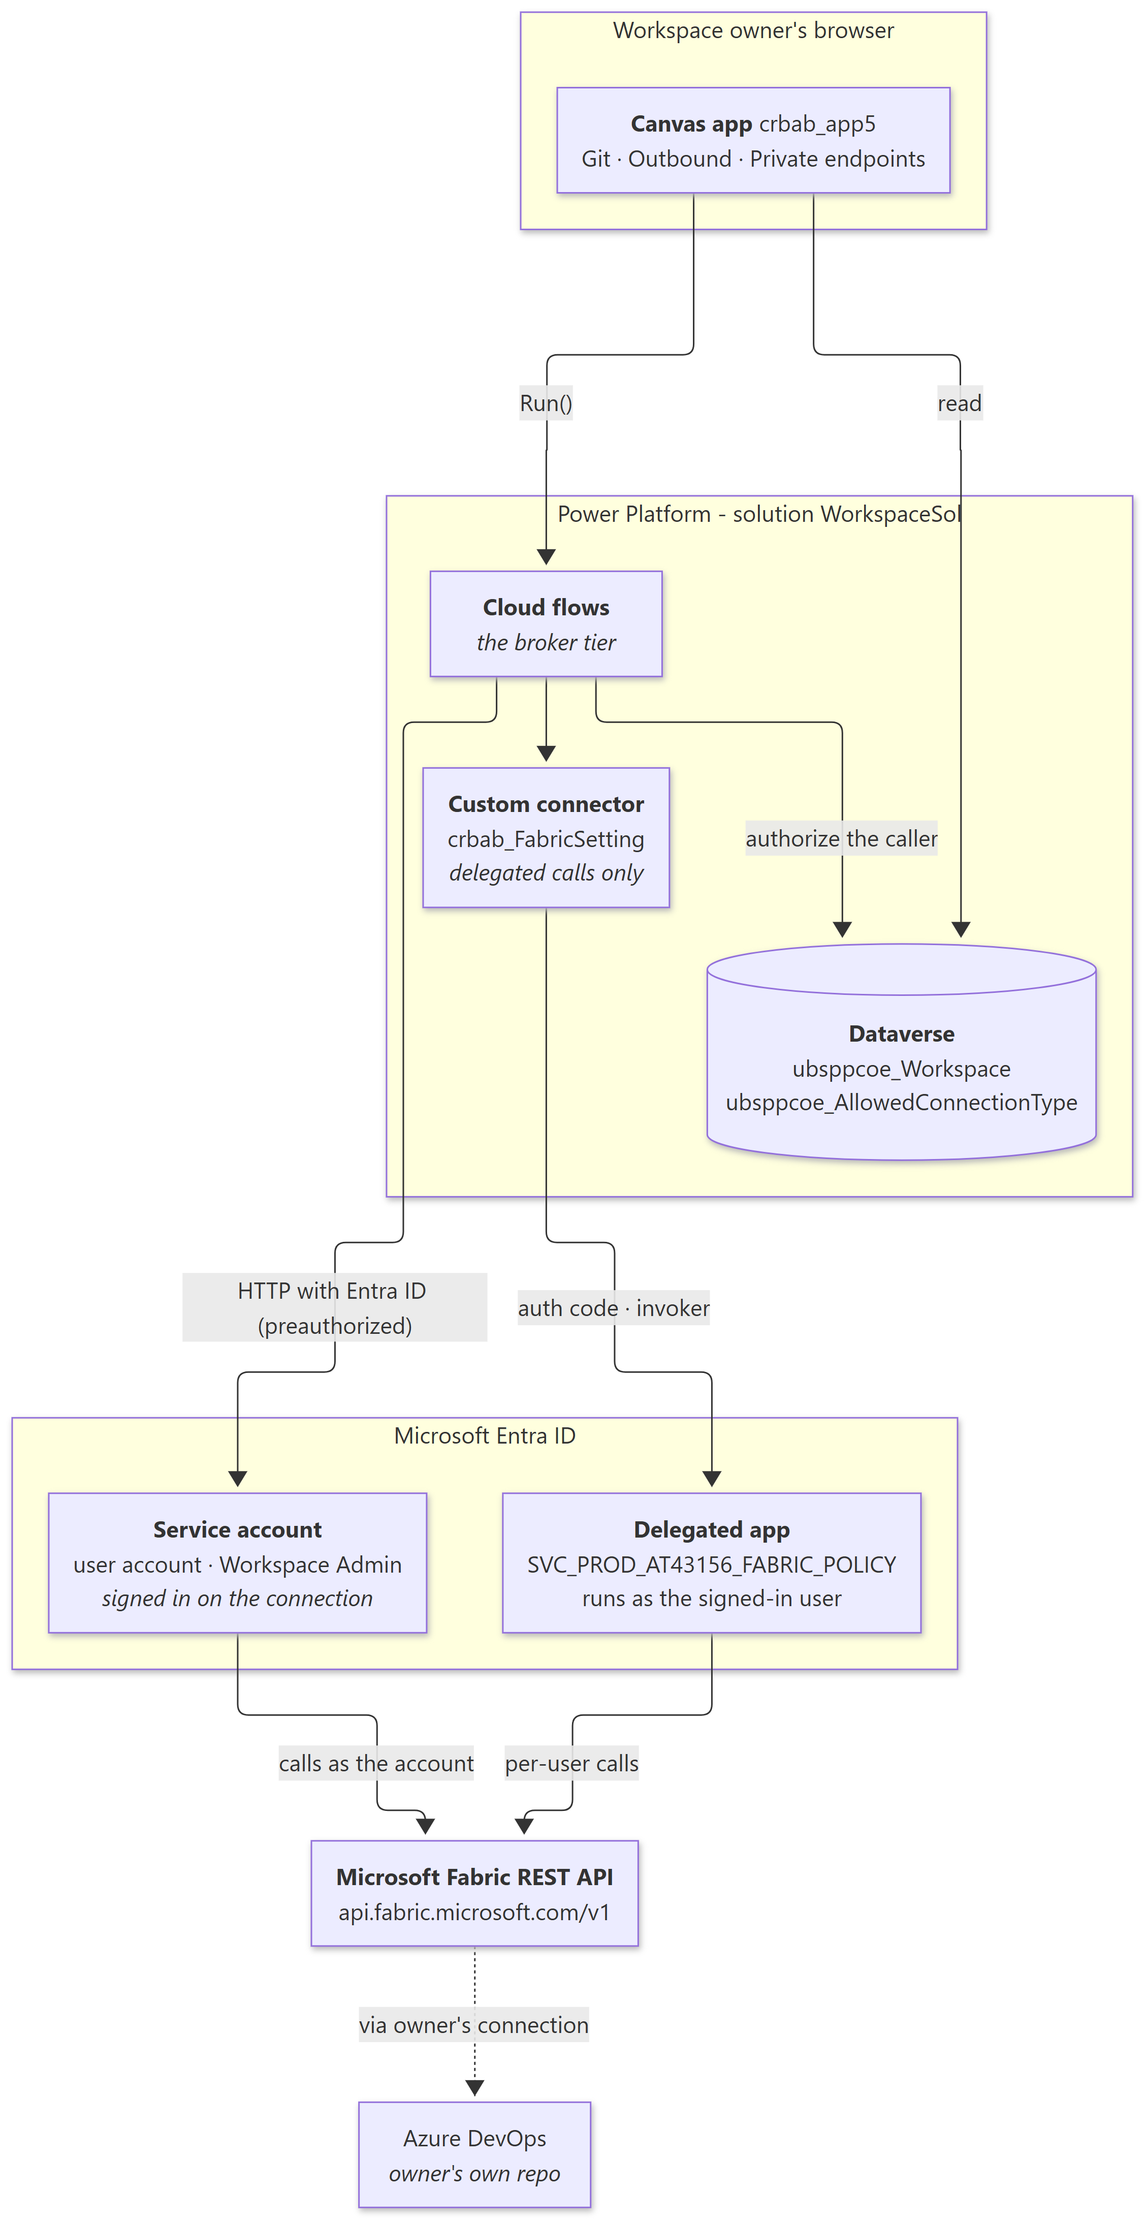

Walking the diagram - one request, end to end
- The owner opens the application and picks a workspace. The picker reads ubsppcoe_Workspace from Dataverse directly, under the owner’s own identity, so the list contains only workspaces they are recorded against. gblWsId is set here and gates every tab (§6).
- The owner acts on a setting, and the application calls a flow. For a read, that is a plain Run(). For a write, the application first writes a request row to Dataverse as the signed-in user and passes the flow nothing but that row’s ID - identity then arrives at the flow as an unforgeable createdby stamp rather than as a parameter anyone could type (§5).
- The flow authorizes the caller. It resolves the requesting user, looks them up against the primary and secondary owner of the target workspace in ubsppcoe_Workspace, and fails closed if they are not there. This is the solution’s only authorization decision, and every write passes through it.
- The flow calls Fabric as the broker. The preauthorized connector attaches the bearer token of the service account its connection signed in as. The flow itself runs no client-credentials grant, builds no Authorization header and stores no token.
- Or, for the three per-user calls, it calls Fabric as the owner. ListMyConnections, ListGateways and AddConnectionRoleAssignment go out through the crbab_FabricSetting custom connector, which runs with runtimeSource: invoker and therefore carries the signed-in user’s rights. These are the only calls that leave the Power Platform under anything other than the broker identity.
- Fabric performs the operation. Where Git is involved, Fabric reaches the owner’s Azure DevOps repository through the owner’s own Azure DevOps connection, which the broker has been granted the User role on but can never read the contents of. No Git credential exists anywhere in the solution (§4).
- The flow records the outcome and answers. Writes stamp the result back onto the Dataverse request row, giving an audit trail of who changed what and whether it worked. The response to the application is a flat set of string fields, and the application refreshes its view by re-reading live state from Fabric - no Fabric state is ever cached locally (§8).
Long-running Fabric operations break this pattern in one place only: Git sync returns 202 with an operation ID, so the application polls a dedicated status flow rather than holding a single run open past the 120-second budget a Power Apps call allows (§6.1).

Four tiers, one responsibility each
Tier | Responsibility | Holds credentials?
Canvas app | Presentation, workspace selection, and every decision requiring the owner’s judgement | No
Cloud flows | The broker. Authorize the caller against Dataverse, call Fabric through the preauthorized connector, flatten the result into a string response | No - the platform holds the connection
Dataverse | The authorization record and reference data. The only component that can answer “does this user own this workspace?” | No
Custom connector | Delegated Fabric calls, and only those. Every brokered call bypasses it entirely | Yes - the delegated app’s secret
The separation matters: the presentation tier holds nothing an attacker would want, and the tier that holds the privileged identity is never directly reachable by a user.
No flow acquires a token, and no flow holds a secret. Brokered Fabric calls use the HTTP with Microsoft Entra ID (preauthorized) connector, which attaches the bearer token for the account its connection signed in as. There is no client-credentials block, no Authorization header and no accessToken variable anywhere in the solution.

What the solution is deliberately not responsible for
Stating the boundary is as useful as stating the scope, because each of these was a considered decision rather than an omission:
Not in scope | Who owns it instead
Holding Git credentials | The owner, through their own Azure DevOps connection in Fabric
Populating the ownership table | External workspace-provisioning automation writes ubsppcoe_Workspace; the solution only reads it
Defining the Dataverse tables | The platform team’s shared ubsppcoe_ solution (§3)
Creating workspaces or granting Fabric roles | Existing estate provisioning and administration
Storing any copy of Fabric state | Fabric. Every read is live against the REST API (§8)
Approving a private endpoint | The data source’s administrator, in the Azure portal (§6.3)
Any Azure RBAC | Nothing in the design requires it, and that is what makes the private-endpoint feature deployable across 4000 workspaces with no Azure onboarding

3. Component inventory

Two prefixes, two solutions, and the tables are not ours
Every component this solution owns carries crbab_. The flows, the canvas app, the crbab_FabricSetting connector, its environment variable and all six connection references.
The Dataverse tables carry ubsppcoe_ and live in a separate, shared solution owned by the platform team. This solution reads and writes them; it does not define them, and they do not travel with its export. A target environment without that shared solution cannot run any of this.

4. Identity model
Two identities, deliberately separated, because they answer two different questions.
 | Broker - the service account | Delegated app - SVC_PROD_AT43156_FABRIC_POLICY
Type | A user account - email and password | A service principal - Entra app registration with a client secret
Client ID | - none. There is no app registration | Per-tenant - read from the app registration
Object ID | Per-tenant - the account’s directory object ID | -
OAuth flow | Signed in on the connection. The connector attaches the token | Authorization code, runs as the signed-in user
Effective rights | Workspace Admin on all managed workspaces | Whatever the calling user already holds
Used for | Every privileged write, and most reads | Calls whose answer depends on who is asking
Reached via | HTTP with Microsoft Entra ID (preauthorized) | The custom connector FabricSetting, runtimeSource: invoker

The one service principal in the solution, and what it is not
SVC_PROD_AT43156_FABRIC_POLICY backs the custom connector FabricSetting, and nothing else. It is the registration whose client ID, client secret and scope list sit on the connector’s Security tab.
It never acts on its own behalf. The connector runs with runtimeSource: invoker, so every call made through it carries the signed-in user’s rights, acquired by authorization code at connection time. The service principal is the vehicle for that delegation, not an identity with privileges of its own - which is why it holds no application permissions and no Fabric role.
Do not confuse it with the broker. The broker is a user account reached through the preauthorized connector; this is a service principal reached through the custom connector. They are different identities, on different connectors, used for different reasons - and granting this one a Fabric role would quietly turn a delegated call into a privileged one.
Its three delegated scopes and the consent behaviour are in the Permissions document, §4.

When delegation is used - and why it is unavoidable
Delegation is used in exactly two structural circumstances, never as a preference:
- The data is per-user. ListMyConnections and ListGateways must return the caller’s list. The service account’s list is not the caller’s list, and there is no API to ask “what would this user see?”
- The right is per-user. AddConnectionRoleAssignment grants the service account access to a connection the owner created. Only the connection’s Owner can grant that, so the call must run as the owner.
Everything else brokers through the service account. Managed private endpoints are the clean illustration: they are workspace-scoped objects with no per-user view, and their writes require Admin. A delegated create would therefore return 403 for every single user of the application. Brokering is not the preferred design there - it is the only design that works.

Fabric access comes from a role on the account, and nothing else
A delegated connection has no roles claim to inspect and no application permissions to configure. The account’s Fabric access requires exactly one thing: a Fabric-side role on the target object - workspace, gateway or connection - granted directly to the account.
There is no tenant setting to enable and no security group to join. Both of those belong to the service-principal path, which this solution does not use.
Symptom | Meaning
401 Unauthorized on every call at once | The connection, not Fabric. The account’s password rotated or expired, MFA or Conditional Access blocked it, or the account was disabled or unlicensed. Re-authenticate the connection
403 Forbidden on one object | The connection is healthy; the account lacks the role on that object
The run history never says “the connection is the problem”. A lapsed credential presents as 401 across the board, so a wholesale failure means suspect the account before suspecting Fabric.
Full detail: the Permissions document.

Git credentials belong to the owner
The application never holds Git credentials. Owners create their own Azure DevOps - Source Control connection in Fabric; the broker is granted the User role on it at runtime and references it by ID, without ever seeing what is inside it. No API the application calls can even reveal the connection’s contents.
A dedicated Git service principal was considered and dropped - it existed only to supply credentials for owners who could not reach Azure DevOps, which is not the case here.
Consequence to communicate to owners: Azure DevOps records the commit as pushed by the connection’s identity, not by the requester. A connection built on a service principal outlives the person who created it; one built on a personal account does not. Which to use is the owner’s decision; a service principal is the recommendation, and nothing in the system enforces it.

5. Authorization boundary
Fabric cannot answer the ownership question. Workspace owners hold no Fabric role that identifies them as owners, so querying roleAssignments on a workspace returns nothing useful about them.
The ownership record therefore lives in Dataverse, in ubsppcoe_Workspace. Every flow that acts on a workspace must confirm the caller appears there as primary or secondary owner, and fail closed if not.

Why write flows cannot trust their own trigger
A Power Apps (V2) trigger receives the user identity as a parameter. Anyone who can reach the flow URL can forge it. That is acceptable for a read and unacceptable for a write.
Write operations therefore use the audit-row pattern:
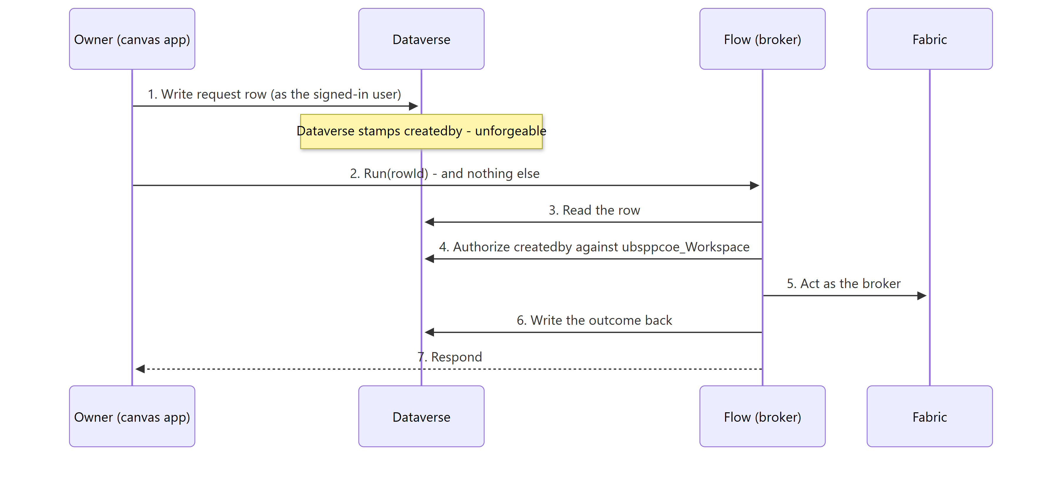
Identity is trusted because of where it was read from, not because of who called. The flow keeps its Power Apps trigger, so the application still receives an immediate answer.
Two deliberate exceptions:
- Read flows may use a plain Power Apps trigger with no row at all.
- AddConnectionRoleAssignment is self-authorizing. The Fabric API only permits a caller to grant roles on a connection they already control, so the boundary is enforced by the API itself.

6. Functional architecture - the three tabs
The canvas app presents a workspace picker followed by three independent tabs. gblWsId is set before anything else and gates every tab - no workspace, no tab. Each tab owns its load block, its error banner and its collections.
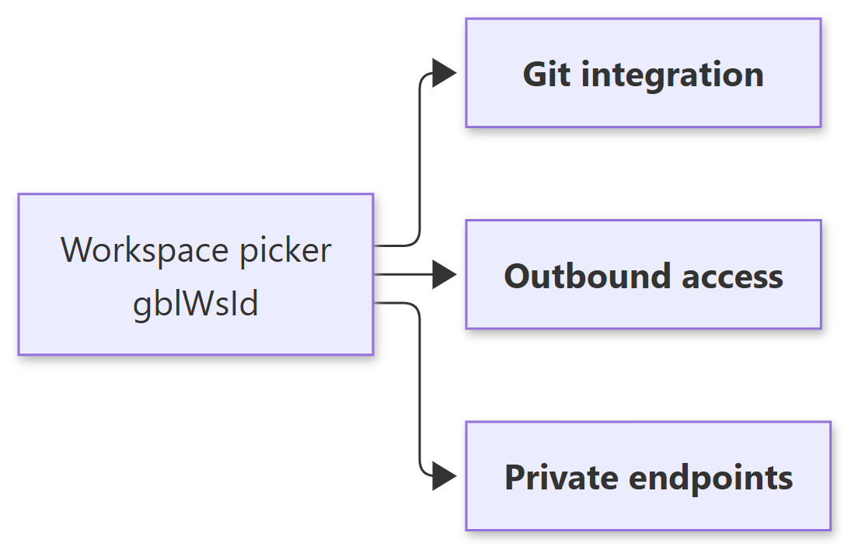

6.1 Git integration
Brokers exactly two operations - connect and disconnect - because those are the only Git actions a Contributor cannot already perform in the Fabric UI. There is no update API for a Git connection, so changing a branch or directory is disconnect + reconnect, which the same two flows cover.
The connect path is a wizard whose shape follows from one insight: the owner cannot sensibly choose an initialization strategy before anyone knows whether both sides hold content. The application therefore connects first, asks Fabric what it wants done, and raises the question only if Fabric declines to decide.
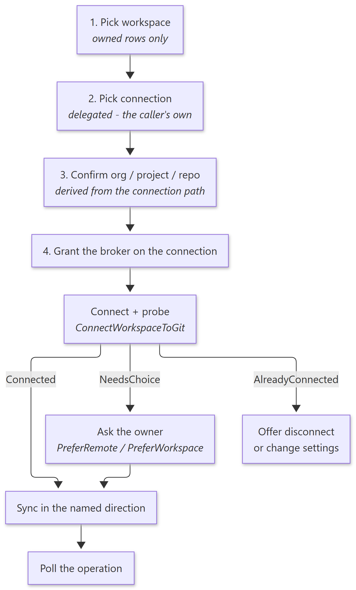
Three structural choices worth carrying:
- The role grant happens on the final step, immediately before the write, so an abandoned wizard leaves no stray role assignments behind.
- Connect and sync are two flows, not one. By the time content moves the workspace is already connected, so calling connect again would fail. The split also keeps each run inside the 120-second response budget a Power Apps call allows.
- Organization, project and repository are derived, never pasted - they come from connectionDetails.path on the connection the owner selected.

6.2 Outbound access
Reads and writes the workspace’s outbound communication policy: allowed connections, allowed gateways, and whether Git integration is permitted outbound. The Outbound Access Protection (OAP) switch itself is read-only - see below.
Everything on this tab lives under networking/communicationPolicy/outbound/* - these are Outbound Access Protection’s own settings. When OAP is off they are inert, so the tab shows nothing but the OAP state and an explanation.
That is a correctness requirement, not tidiness. With OAP off there is no outbound restriction at all, so a greyed-out Allow Git integration toggle and an empty Allowed gateways list would each tell the owner the exact opposite of the truth about their workspace’s posture. Hide, do not disable.
GetOutboundRules returns an ETag that SetOutboundRules must echo - optimistic concurrency, so two owners editing simultaneously cannot silently overwrite each other.

The OAP setting itself is read-only - by design
The tab displays whether Outbound Access Protection is enabled on the workspace, and never offers to change it. This is visible in the flow inventory (§7): GetOAPSetting reads the state, and there is deliberately no SetOAPSetting to pair with it. Every other setting on the tab has both.
That asymmetry is a governance decision, not a gap in the implementation:
- OAP is set once, during workspace creation. It is decided by the process that provisions the workspace and by whoever approved that request - it is a property of the posture the workspace was created with, not a runtime preference.
- A workspace owner must not be able to turn it off. Disabling OAP lifts every outbound restriction on the workspace in a single action: the allow-lists this tab maintains stop applying entirely, and the workspace can once again reach anything. Handing that switch to 4000 owners would give away in one click exactly the control the rest of the solution is built to hold (§1).
- Enabling it is equally out of scope. An owner switching OAP on for a workspace whose data flows were never designed around an allow-list would break those flows immediately, and could not undo it - because reverting means turning OAP off, which they also cannot do.
What the owner may do is work inside the posture they were given: maintain the allow-lists and the Git toggle that OAP enforces. Changing the posture itself is a request to the workspace-provisioning process, and stays outside this application.

6.3 Private endpoints
Manages the workspace’s managed private endpoints - the outbound private-link connections Fabric uses to reach data sources that are not publicly reachable. Three operations: list, create, delete.
Structurally the simplest tab: three HTTP calls against one resource, all brokered, all covered by a role the service account already holds. No connector change, no new scope, no re-consent, no new Fabric permission, and no Azure RBAC at all - the Azure-side rights sit entirely with the approver at the far end. That is what makes the feature deployable across 4000 workspaces with no Azure onboarding, and it is the property most worth protecting.
Two independent status fields, and the tab must show both. Conflating them is the likeliest design mistake here:
Field | Owned by | Answers
provisioningState | Fabric | Did Fabric manage to create the endpoint?
connectionState.status | The data source admin, in the Azure portal | Has the far end accepted the request?
Succeeded + Pending is the normal steady state for minutes to days after creation, and the endpoint is unusable until it reaches Approved. The tab must not present that as an error. connectionState is genuinely absent on a freshly created row, so every read of it must be null-safe.

Choosing the sub-resource
A private endpoint targets a resource and a sub-resource - Azure’s private-link group ID. One storage account requires separate endpoints for blob and dfs, each approved separately.
The sub-resource is a property of the resource type, not the resource, so the application parses the type out of the resource ID and filters a Dataverse lookup table on it:
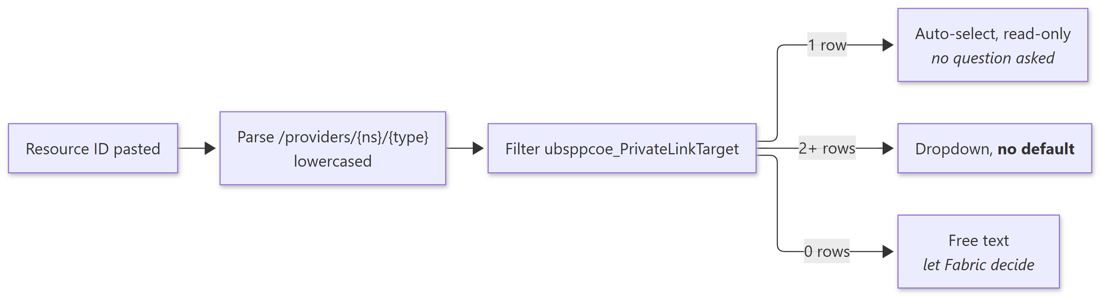
Around fifteen types resolve 1:1. Five are genuinely ambiguous - storage, Cosmos DB, Synapse, Purview and Databricks - where the resource ID cannot distinguish the options and only the owner knows which their workload needs.
There is deliberately no default on that dropdown, because of the sharper of the two failure modes:
Failure | What happens
Sub-resource invalid for the type | Fabric accepts the POST with 201 - it does not validate - then provisioning fails. The row shows Failed; the owner deletes and recreates. Visible and self-correcting
Sub-resource valid but not the one needed | Provisions to Succeeded, gets approved, connectionState reads Approved - and the workload still fails, because its traffic goes to a hostname this endpoint does not cover. Every signal the application can see says success
The second is why the picker constrains rather than guesses, and why the application always re-lists after a create: outcome: Created means the request was accepted, not that the endpoint works.
An endpoint showing Failed needs no diagnosis and no support ticket - it means the sub-resource was wrong. Delete it and create the right one.

7. Flow inventory
All flows live in the solution’s Workflows folder as unpacked solution JSON. They are edited in the maker portal and re-exported, and are never hand-edited.
19 flows are built. Every flow the application calls is added to the canvas app explicitly.

Git integration - 7 flows
Flow | Identity | Purpose
GetWorkspaceGitState | Service account | Read the current connection so the tab knows what to offer
ListMyConnections | Delegated | The caller’s own Azure DevOps connections, filtered client-side
AddConnectionRoleAssignment | Delegated | Grant the service account the User role on the owner’s connection
ConnectWorkspaceToGit | Service account | Stage 1 - connect, then probe for the required sync direction
SyncWorkspaceWithGit | Service account | Stage 2 - move the content
DisconnectWorkspaceFromGit | Service account | Disconnect. Also the only route to a branch or directory change
GetGitOperationStatus | Service account | Report the state of a long-running operation. Advances nothing

Networking - 8 flows
Flow | Identity | Purpose
GetOAPSetting | Service account | Is Outbound Access Protection enabled?
GetOutboundRules / SetOutboundRules | Service account | Allowed outbound connections, with ETag concurrency
GetGatewayRules / SetGatewayRules | Service account | Allowed gateways
GetGitPolicy / SetGitPolicy | Service account | Outbound Git permission
ListGateways | Delegated | Gateways the caller can actually see

Private endpoints - 3 flows
Flow | Identity | Purpose
ListPrivateEndpoints | Service account | Paged read of the workspace’s endpoints
CreatePrivateEndpoint | Service account | Request a new endpoint. Returns 201 immediately, no polling
DeletePrivateEndpoint | Service account | Remove one
Built and tested 2026-09-02. Build documentation for these three flows lives in the engineering documentation set.
Those three build documents still describe the token-flow model - a GetFabricToken child call and an Authorization header. The Fabric routes, bodies and error handling they specify are accurate; only the auth mechanism has since changed to the preauthorized connector.

8. Data model
Table | Role
ubsppcoe_Workspace | The authorization boundary. Workspace ID plus primary and secondary owner. Populated externally
ubsppcoe_AllowedConnectionType | Reference data for the outbound tab
ubsppcoe_PrivateLinkTarget | Resource type → valid private-link sub-resources. One row per pair, seeded from the solution’s PrivateLinkTargets.csv seed file. Seed rows are per environment
ubsppcoe_Log | Who did what, when and with what outcome - and the row that carries unforgeable identity into a write flow
None of these tables is in WorkspaceSol. They carry the ubsppcoe_ prefix and belong to the platform team’s shared solution, so none travels with this solution’s export - see §3. ubsppcoe_Workspace is populated by external workspace-provisioning automation and is out of scope for this solution.

Two rules that hold across all tables
- Create tables in the maker portal, never by editing customizations.xml.
- Do not cache Fabric state in Dataverse. Fabric owns that state, the GET APIs return it live, and a local copy is only ever a second source of truth to reconcile.

Why ubsppcoe_PrivateLinkTarget is flat
It is a flat type → sub-resource table rather than a parent/child model on purpose. The picker is a filter on one table, and supporting a newly added Azure source is one row - addable by anyone with Dataverse access, with no application republish. That matters because Fabric’s supported-source list grows faster than a shipped list would realistically be maintained.
There is also no API that could replace it. Fabric publishes nothing. Azure’s privateLinkResources call is authoritative but requires Reader RBAC on every target resource - which would mean onboarding the broker into every subscription any owner might target, and would destroy the single best property of the feature (§6.3).

9. Integration surface - Fabric REST API
Base: https://api.fabric.microsoft.com/v1

Git endpoints
Endpoint | Behaviour
GET /workspaces/{id}/git/connection | Returns 200 + NotConnected when disconnected - not 404
POST .../git/connect | Synchronous
PATCH .../git/myGitCredentials | Per-identity; the broker must set ConfiguredConnection
POST .../git/initializeConnection | Returns requiredAction, workspaceHead, remoteCommitHash - or 202 with an empty body
GET .../git/status | May return 202 on a cold workspace
POST .../git/commitToGit | 202 + x-ms-operation-id
POST .../git/updateFromGit | 202 + x-ms-operation-id
POST .../git/disconnect | Synchronous
GET /operations/{id} and /result | Long-running-operation polling
State enumerations
- gitConnectionState: NotConnected · Connected · ConnectedAndInitialized
- requiredAction: CommitToGit · UpdateFromGit · None
Sync request bodies - what is actually required
API | Required | Optional
commitToGit | mode | workspaceHead, comment, items
updateFromGit | remoteCommitHash | workspaceHead, conflictResolution, options
workspaceHead is optional in both and “may be null only after Initialize Connection”. Sending a stale value returns WorkspaceHeadMismatch.

Networking and private-endpoint endpoints
Endpoint | Purpose
GET/PATCH /workspaces/{id}/networking/communicationPolicy/outbound/* | Outbound access settings, ETag-guarded
GET /gateways · GET /gateways/{id}/roleAssignments | Gateway discovery. Role assignments need ConnectionCreator or higher
GET /connections · POST /connections/{id}/roleAssignments | Connection discovery and role grant, both delegated
GET/POST/DELETE /workspaces/{id}/managedPrivateEndpoints | Managed private endpoints

10. Design decisions and their rationale
Decision | Rationale
Broker only connect and disconnect for Git | Contributors already commit, update and read status in the Fabric UI. Brokering them would add four flows and two tables while widening the broker’s exposure for no functional gain
Dataverse, not Fabric, is the authorization boundary | Fabric holds no record that identifies a workspace owner; the ownership fact exists only in Dataverse
Writes authorize on createdby, not on a trigger parameter | A Power Apps trigger parameter is forgeable by anyone who can reach the flow URL. A Dataverse createdby stamp is not
A dedicated broker identity, not the existing tenant-wide one | An application exposed to 4000 workspace owners must not run with more permissions than it is needed to have
The broker is a service account reached through the preauthorized connector, not a service principal | The connector attaches the token itself, so the solution holds no client secret, needs no app registration for the broker, and depends on no tenant setting. The cost is a user-account credential that must be kept permanently valid - see the Security document, §4
Owners supply their own Git connection | Keeps Git credentials entirely outside the solution, and makes credential durability the owner’s explicit choice
The OAP switch is displayed but never written | Outbound Access Protection is set during workspace creation and defines the workspace’s posture. An owner able to disable it could lift every outbound restriction in one action, which would defeat the allow-lists the tab exists to maintain (§6.2)
Connect and sync are separate flows | Respects the 120-second Power Apps response budget, and avoids re-calling connect on an already-connected workspace
Never branch on the initialization strategy | The strategy tells Fabric how to resolve initialization; requiredAction tells the application which way to sync. They are not the same question
No local cache of Fabric state | Avoids a second source of truth that must be reconciled. The GET APIs are live and authoritative
No Azure RBAC anywhere in the design | Keeps managed private endpoints deployable across 4000 workspaces with zero Azure onboarding
Treat “already exists” as success | A duplicate role grant returns 409; a re-initialized connection returns 409. The end state is the one that was wanted - failing the run would show the user an error describing exactly the state they asked for

11. Architectural constraints and known limitations

Platform constraints
Constraint | Consequence
No update API for a Git connection | Changing a branch or directory is disconnect + connect + initialize. There is no PATCH
directoryName must already exist in the branch | Connect returns GitProviderResourceNotFound otherwise. The Fabric portal offers to create the folder; the REST API has no equivalent. Folder names are case-sensitive
Sync is all-or-nothing and validates item models | An item holding a relative OneLake reference to a table absent from the target workspace fails the entire operation with GitSyncFailed. The real cause appears only in error.moreDetails from GET /operations/{id}
initializeConnection may return 202 with no body | None of the three response fields exist; the operation must be polled before the sync direction is known
ListGateways pages are capped at five | The pagination loop stops after five pages by design. A truncated list is returned that looks complete
Fabric does not validate private-endpoint sub-resources | An invalid sub-resource is accepted with 201 and fails later at provisioning (§6.3)
Fabric Git restriction, December 1 2026 | Users without read-write permission on workspace items will not be able to use Git integration. Sensitivity labels and protection policies may block Git operations even for Contributors. Accepted risk; monitor

Power Platform conventions that the implementation depends on
These are not preferences - each was established after a real defect, and departing from them reintroduces it.
Convention | Why
Every Power Apps response field is a string | A field declared boolean but emitted through @{...} interpolation returns the string "true". Validation applies to the whole response, so the application then cannot read any field of that flow. Emit string(...) and coerce in Power Fx
Power Apps trigger inputs are positional | They are stored as text, text_1, text_2. The name shown is only a title. Inserting an input in the middle silently re-wires everything after it
Make trigger inputs required | A blank optional input is omitted from the trigger body entirely, and is indistinguishable in run history from one that was never wired. This is how an owner’s initialization-strategy choice went missing with no error
Re-add a flow to the application after any trigger change | Power Apps caches the signature at bind time
Respond on Succeeded or Failed | A skipped action satisfies neither run-after condition, so a Fabric error ends the run with no response at all and the application shows a hard error instead of a readable message. This defect appeared independently in three separate flows
Gate “empty” messages on a loaded flag | A blank collection is falsy, so “no results” flashes on every workspace that does have some
Guard optional trigger reads | triggerBody()?['text_2'] must be wrapped in coalesce(…,''). The unguarded form throws

